Digital Image Processing Homework 2 Report

0550222 葉胤呈

1. **Abstraction**

In this homework, white balance and change of the color style are implemented. One suggests that regression models can be applied on these two fields and it can achieve surprisingly good results. In the following sections, this report will guide you down to the model-design details and results.

1. **Regression Model for White Balance**

For the observation on the input image (Figure 4), one can found that the RGB value on the color checker are all out of tune. We learn that the colors on the color checker widely scatter on the color space. Thus, we then assuming that finding the mapping (Figure X) from input RGB space to the target RGB space, which is white-balanced, on the color checker can mapping most of colors (even the color is not on the color checker ) to the right place on the target RGB domain.

**Figure 1**. Input RGB Performs a Non-linear Mapping to Target RGB Set

Then, we applied the linear regression model (Figure 2) on this mapping. The RGB from a given input-image pixel will be extracted and pass through the feature kernel. The Feature kernel works as getting the mutual information from channels. As the comparison, one has tried to fit the regression model by directly input the RGB value. However, the results seem really incorrect. Therefore, one gradually added high-order term into the feature kernel. For second-order terms, they made great contributions on minimizing the mean square error of the linear regression and improve the output image quality. After all of the second order terms are applied, there are still some details on the background are loss. Thus, one added three order-terms to the feature kernel. However, the model was obviously over-fitted. The details on the background became color chucks. Back to the second order term, one found that the G channel and B channel have larger mean square error. Then, I add some of the terms related to G and B channels and get the best feature kernel is as following,

$$Feature=[ R G B R*G G*B R*B R*R G*G B*B R*G*B G*G*B B*B*G]$$

Then, we trained this model over 24,000 pixels. The mean square error over the training set are in Figure 3.

Input Pixel(x,y)

Target R Channel Value

$${(R,G,B)}_{1*3}$$

Feature Kernel

$$f_{1*dim}$$

Linear Regression

$$r_{target}=w_{1*dim}*{{(f}_{1*dim})}^{T}$$

**Figure 2.** Training Model for R Channel



**Figure 3**. Root Mean Square Error of each channel over each set. (Set size = 6\*4; Total Sets: 100 sets)

The results are Figure 4 and Figure 5. One can observe that the output image gained much better balanced color then input image. The input image as a whole has its color a little bit yellow-doped.

|  |
| --- |
| Figure 4. Input Image |
| C:\Users\DeanYeh\AppData\Local\Microsoft\Windows\INetCache\Content.Word\input1_WB.BMP  Figure 5. White-Balanced Image by Regression Method |

1. **Regression Model for Color Style**

Applying the same method, one can impose a particular style on images. In this homework, the input image is going to cast the input image into an autumn scene. From my observation on the input image, one suggests that replacing on the green color to some brown series color and upscaling the gray level of the last row on the original color checker can bring some autumn feeling to the scene. Follow the same step on last section, we transform the color space from original color checker (Figure 5) to the autumn-style color checker (Figure 6).

|  |  |
| --- | --- |
| Figure 5. Original Color Checker | Figure 6. Autumn-Style Color Checker |

The result is in Figure 8. Compare with the original input image (Figure 5), one can feel that the plants goes brown and the sky turns gloom. Also, the color of the castle on the middle does not change a lot.

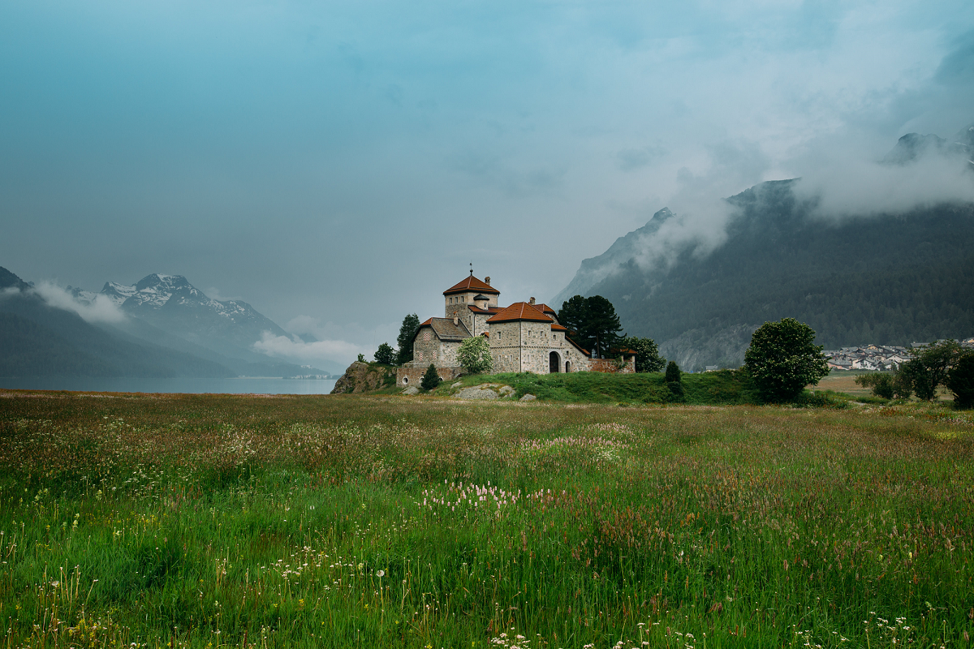

Figure 7. Original Input Image

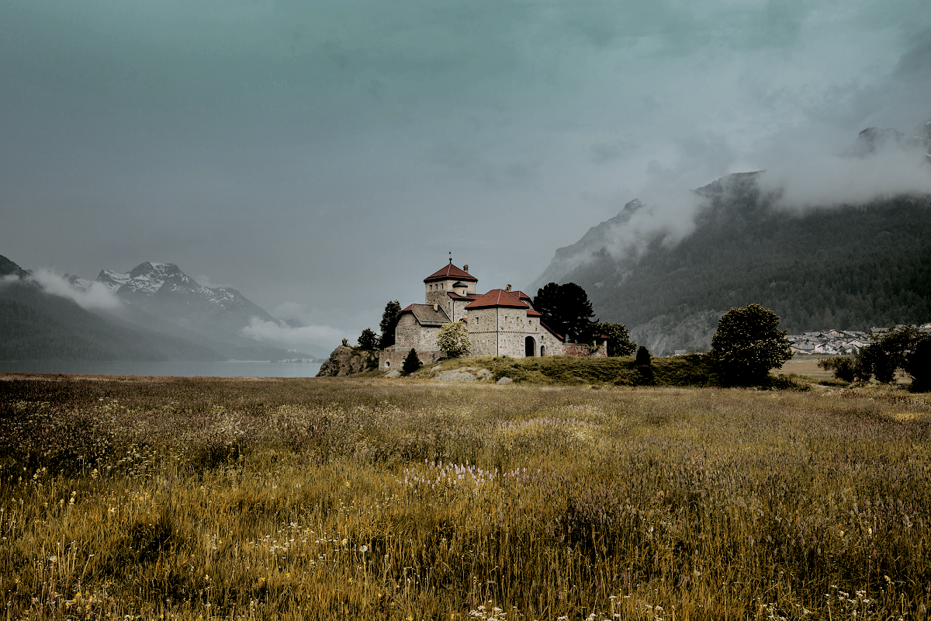

Figure 8. Autumn-Style Image